**Project Key**

One stop online platform for property investors, managers, owners, tenants and service providers. It will analyze the data sets across different platforms and provide the end user with a complete analysis about the Geographical location Property market

Tasks

* Clean, standardise data
* Build a data warehouse with fact & dimension tables.
* Build SSRS and Power BI reports

Results

* Choose city and suburb and distance, display transport/school/property value/rental value/crime rate within a particular distance/radius eg. 1, 5 km from the input suburb.
* Generate financial report eg. Rental incomes vs Expenses for landlords.
* Display forecasted property value within 1, 5 and 10-year value.

Sprints

**Sprint 1: Standardise Dataset**

Given raw dataset, standardize datasets for public transport in Australia

Given raw dataset, standardize datasets for local school.

Given raw dataset, standardize dataset for Rental Median per suburb, city

Given raw dataset, standardize the dataset for Median Property Value per suburb

Given raw dataset, standardize the dataset for Crime rate of each suburb and city.

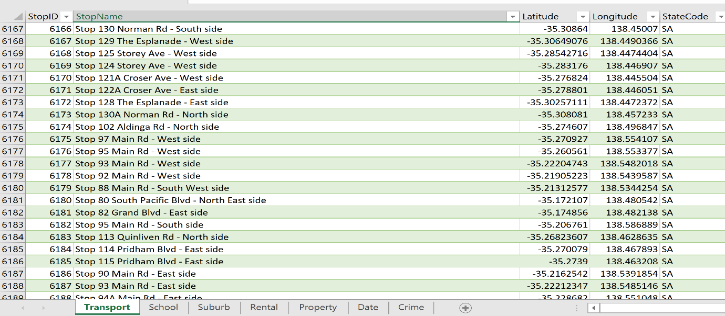

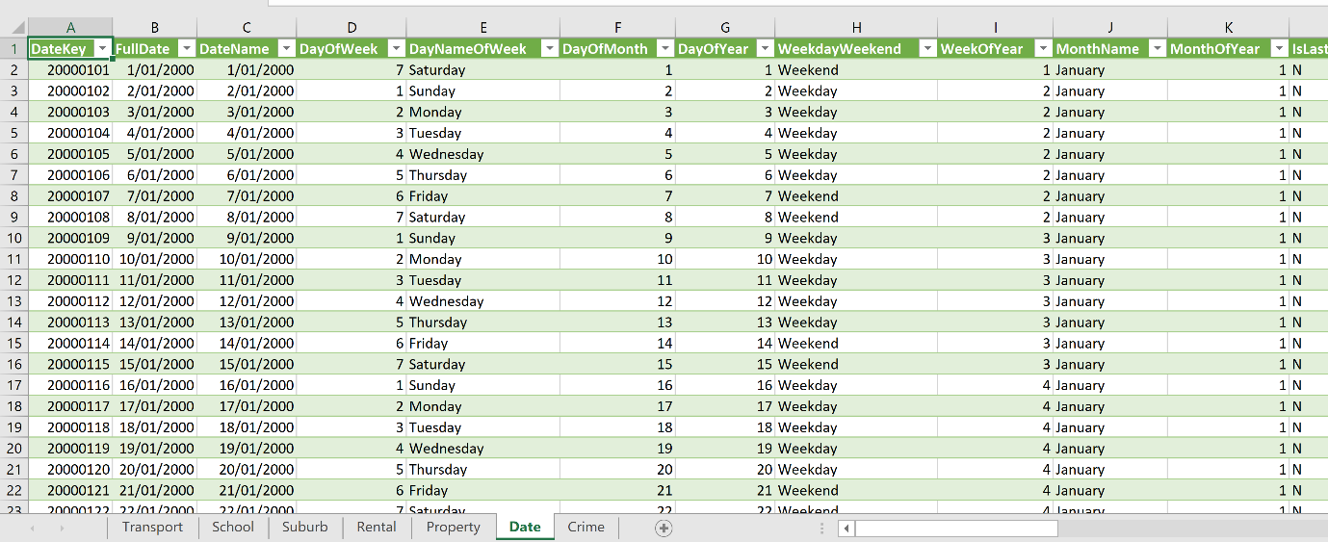

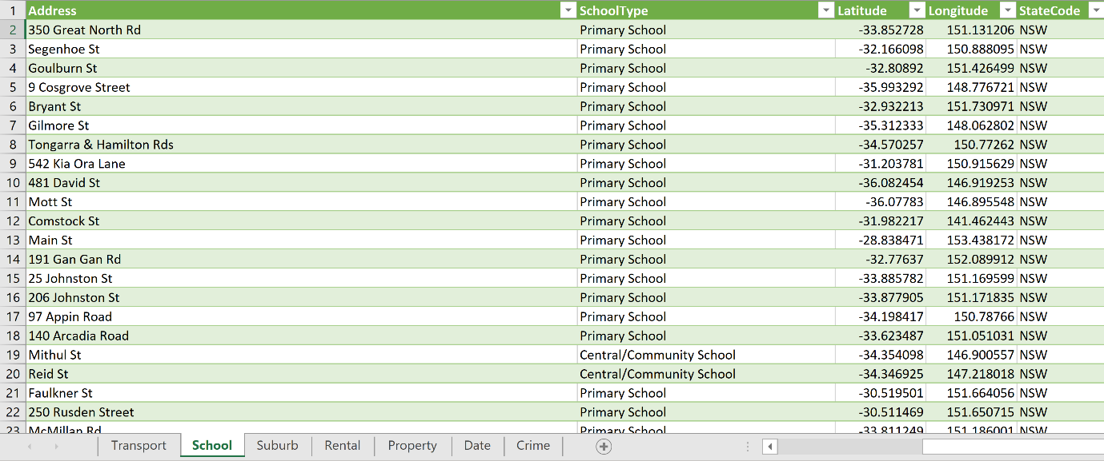

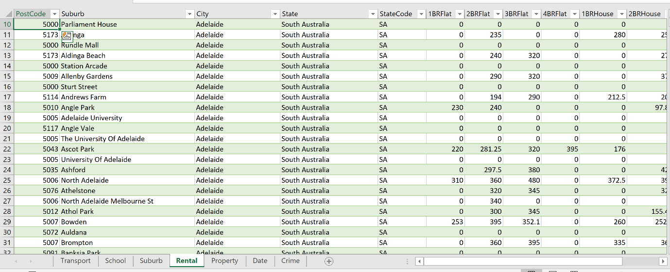

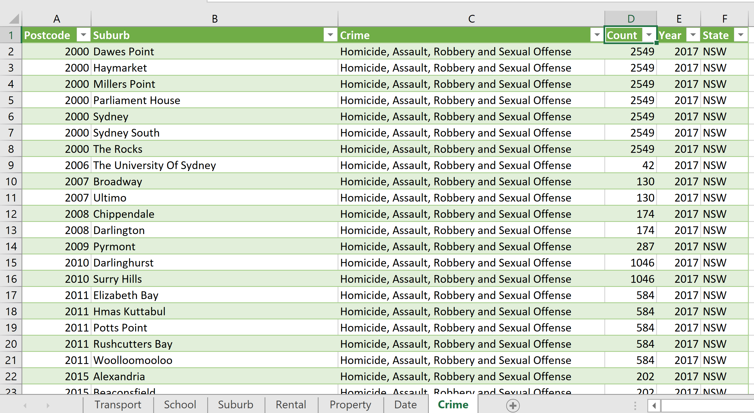

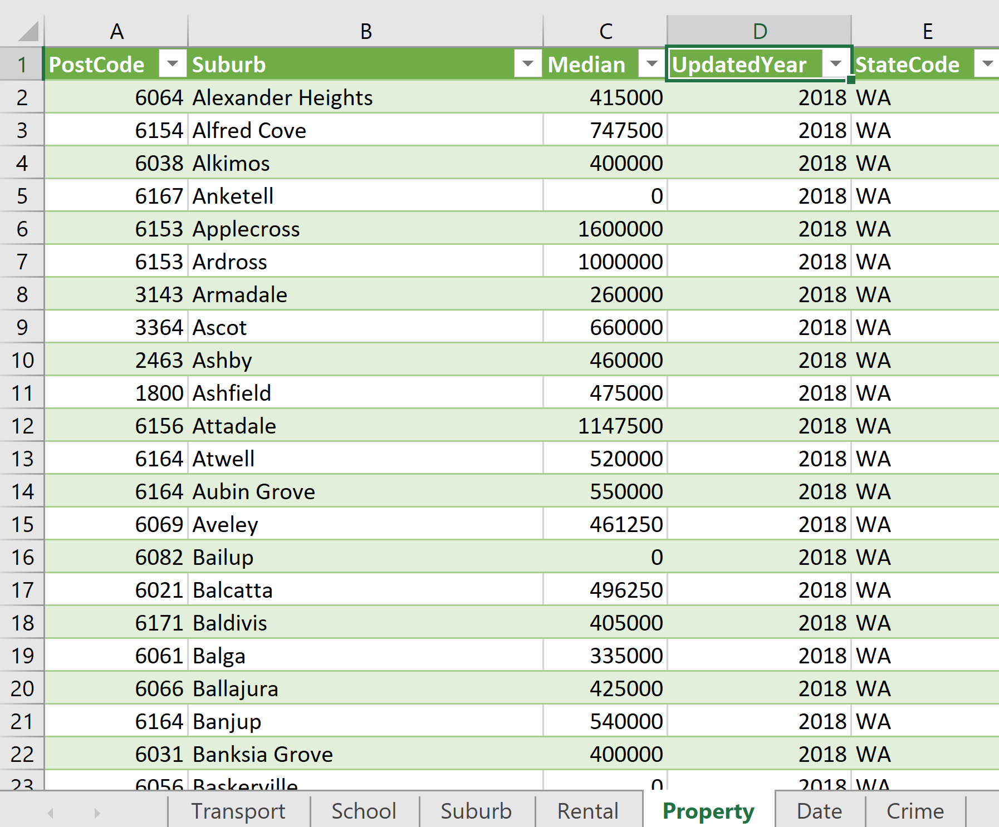

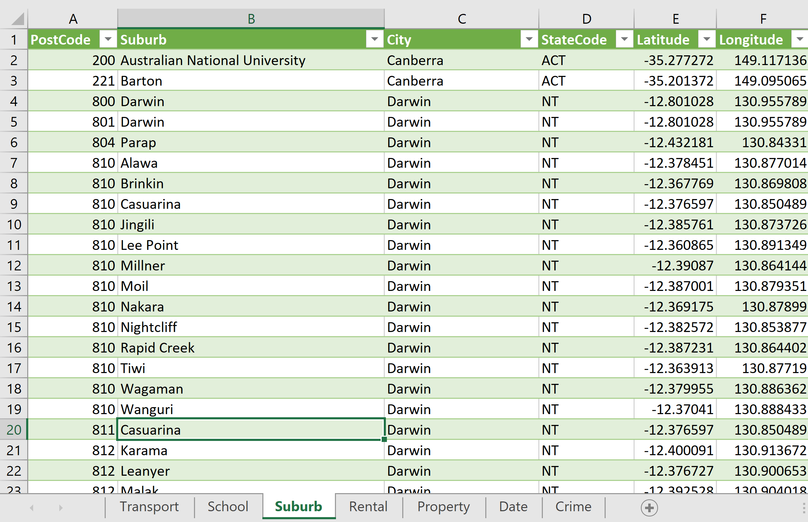

**Sprint 2: Design Datawarehouse & Build SSIS package**

|  |
| --- |
| Using Suburb and City Dataset, design a Dim table - DimGeography with State / City / District / Postcode / Suburb / Lon / Lat.  DimTransport: Load public transport data to StgTransport table  DimState with DWStateKey, StateCode and StateName  Design DimAuLocalSchool tables for Aus local school  Design FactCrimeByYear  Design FactSuburbRentalMedian  Design Fact table – FactMedianPropertyValueByYear  Design Fact table FactSuburbPopulation      **Screenshot 1 of Load DimGeography**    **Screenshot 2 of Load DimGeography Detailed**      **Screenshot 1 of Load DimTransport**      **Screenshots 1 and 2 of Load DimTransport Detailed**    **Screenshot 1 of Load DimAuLocalSchool**    **Screenshot 1 of Load DimAuLocalSchool Detailed**    **Screenshot 1 of Load FactSuburbRentalMedian**      **Screenshots 1 and 2 of Load FactSuburbRentalMedian Detailed**    **Screenshot 1 of query of DimPropertyType**    **Screenshot 1 of DimPropertyValue**      **Screenshots 1 and 2 of DimPropertyValue Detailed**    **Screenshot 1 of FactMedianPropertyValueByYear**    **Screenshot 1 of FactMedianPropertyValueByYear Detailed**    **Screenshot 1 of FactCrimeByYear**    **Screenshot 1 of FactCrimeByYear Detailed**      **Screenshot 1 of Load DimState Detailed**  **Sprint 3: Build SSRS Report**  Given suburb and city, display median rental value, median yearly income, and value changes of the property within 1 km radius.  Given suburb and city, display local public transport within 1km radius - update data sets.  Given suburb and city, display local schools within 1km radius.  Given suburb and city, display crime rate within 1 km radius.  Given suburb and city, display property value of the area in Column chart and line chart of 1 year, 5 years and 10 years value  Given suburb and city, display median rental value, median yearly income, and value changes of the property within 1 km radius.    **Screenshot 1 Design**      **Screenshot 2 of Report Preview**  Given suburb and city, display local public transport within 1km radius    **Screenshot 1 of Report Task Design**    **Screenshot 2 of Report Task Preview**  Given suburb and city, display local schools within 1km radius    **Screenshot 1 of Report Task Design**    **Screenshot 2 of Report Task Preview**    Given suburb and city, display crime rate within 1 km radius    **Screenshot 1 of Report Task Design**    **Screenshot 2 of Report Task Preview**    **Screenshot 2 of Report Task Preview**  Given suburb and city, display property value of the area in Column chart and line chart of 1 year,5 years and 10 years value    **Screenshot 1 of Report Task Design**      **Screenshot 2 of Report Task Preview** |
| **Sprint 4: Build Power BI Dashboard from the designed Datawarehouse**  Given suburb and city, display median rental value, median yearly income, and value changes of the property within 1 km radius  Given suburb and city, display local public transport within 1km radius  Given suburb and city, display local schools within 1km radius  Given suburb and city, display crime rate within 1 km radius  Given suburb and city, display property value of the area within 1km radius in Column chart and line chart of 1 year, 5 years and 10 years value |
| Build Monthly Property financial report on Power BI- rental income vs expense.  Line chart of Property Value Changes in the suburb of 1,5 and 10 years on DW.  Build Pie chart of all expense categories on DW.  Build Crime rate Map around the given input property on Power BI.  Build Custom map display Public transport within 1km radius of given input property  **Monthly Property Financial Report : Rental income vs expense amount**  So when we clicked on the month name, it will show the Sum of Rental income vs Sum of  total expense amount in the charts.    **Line chart of Property Value Changes in the Suburb of 1,5 and 10 years on**  **DW**  Given the Suburb name, we can see the predicted median property value in the next 5  years, 10 years and 15 years.    **Pie chart of all expense categories on DW:**  So, I make an expense categories pie chart to display type of property which account for  corresponding proportions in the chart. We can see Senior housing property type has the  largest percentage account in the chart.    **Given input property, displaying public transport within 1km on custom**  **map.**  When we click on the Property Name “NEW ADD TEST” With DWPROPERTYKEY = “2470”,  this will filter the other charts: public transport chart and public transport locations on custom  map. So, you will see the immediate resulted Station Transport Name with it’s kilometres of  distance between the Property input.      Using Parameters to display property median value changes within 1km in Power BI    **Using Parameters to display Public Transport within 1km in Power BI:**  By adding store procedure and connect to the designed database, I have entered given  Suburb and City Name in parameters to display current public transport within 1km.      **Using Parameters to display Public School within 1km in Power BI:** using the  same technique, we can now enter Suburb and City name in this case to display local  schools within 1km.    **Using Parameters to display crime rate within 1km in Power BI**    **Use column chart to display median value changes of properties that are**  **within 1km radius of given Suburb and City.** |
|  |
|  |